Use Case - Document

Module Name:Access

Use Case Name: Admin providing access to Policy holder, Agent and Policy details

# ID:105

# Name:Access

# Title:

Admin Providing Access

# Description:

Admin will provide the access to the policy holder, agent and policy details after validating the details. Once the user is validated admin will provide the access

# Use Case Diagram:

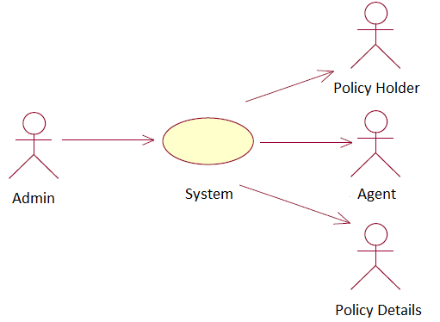

# Pre-Conditions:

1. Authenticated Policy Holder
2. Agent Should be Authorised
3. Valid Policy Details

# Post-Conditions:

1. Access will be provided to Authorised Policy holder
2. Access will be provided to Authorised Agent
3. Access will be provided to Valid Policy details

# Primary Flow:

1. First the Admin will check for the valid details in the Database
2. If the details are correct it will grant access to the Policy holder, Agent and Valid policy details

# Alternate Flow:

1. Policy Holder is invalid

If the Policy holder is invalid then it will not provide the access and will display the error message .

1. Agent is invalid

If the Agent is invalid then it will not provide the access and will display the error message .

3. Invalid Policy Details

If the Policy details are invalid then it will not provide the access and will display the error message .

# Exception Flow:

1. <<Flow 1>>
   * ..
   * ..

# Data:

1. Details about the Policy holder ,Agent and Policy Details

# Screen Shots:

1. <<Screen 1>>